**User Guide for Sentiment Scribe Insights Engine**

**What is this tool?**

The **Sentiment Scribe Insights Engine** is an online application that analyzes text input to extract **sentiment insights** and other relevant data from your content. It helps you understand the emotional tone, key themes, and sentiments in your text.

**How to Use the Tool**

**Step 1: Open the Link**

Go to the web address:  
<https://sentiment-scribe-insights-engine.lovable.app/>

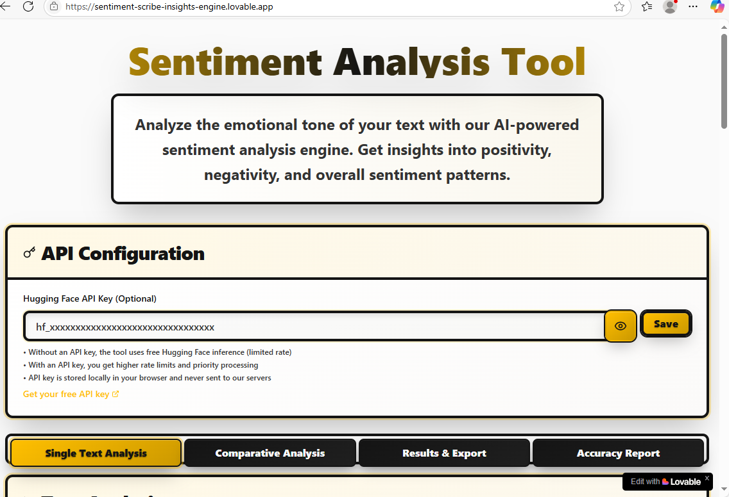

**Step 2: Input Your Text**

* Find the text input box on the webpage.
* Paste or type the text you want to analyze. It can be anything: reviews, comments, feedback, articles, social media posts, etc.

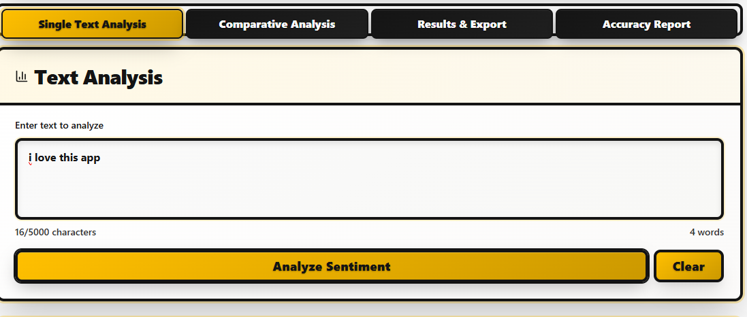

**Step 3: Submit for Analysis**

* Click the **Analyze** or **Submit** button (the label may vary).
* The tool will process your input and generate insights.



**Step 4: Review the Output**

* The output will display sentiment scores, key emotional tones, and possible topics/themes.
* Some results may include visual graphs or summary insights.

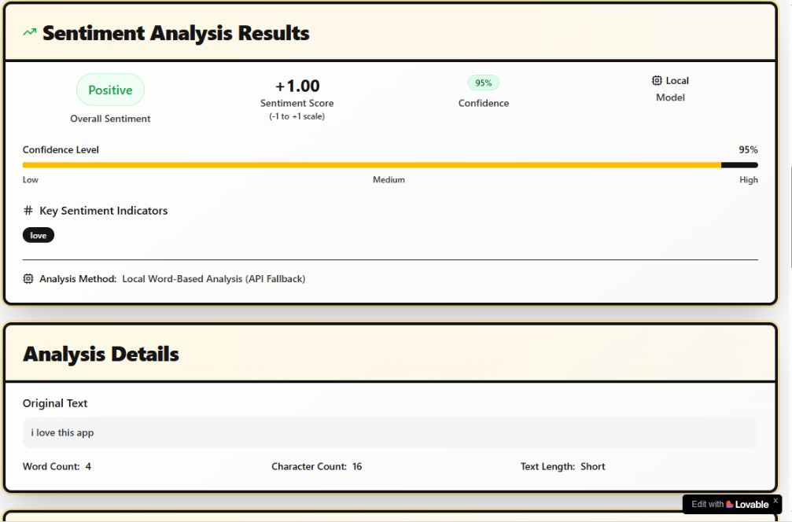

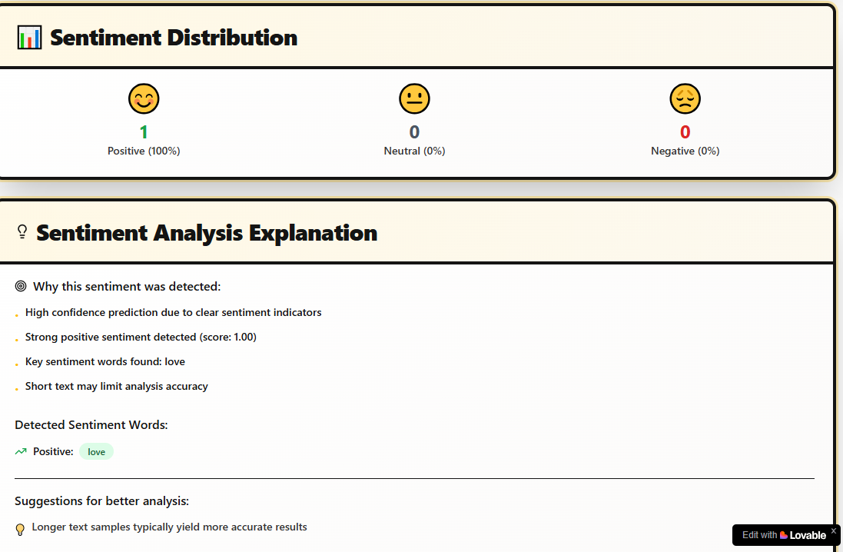

**Example Use Cases & Inputs**

**Example 1: Product Review Sentiment**

**Input:**

"I love the new smartphone! The battery lasts all day, and the camera quality is amazing. However, the screen is a bit too fragile."

**Expected Output:**

* Overall positive sentiment with some negative nuance.
* Key positive themes: battery life, camera quality.
* Negative theme: screen durability.

**Example 2: Customer Feedback**

**Input:**

"The service was disappointing. I waited for 30 minutes, and the staff was not helpful. I will not come back."

**Expected Output:**

* Strongly negative sentiment.
* Themes: poor service, long wait times, unhelpful staff.

**Example 3: Social Media Post**

**Input:**

"I had an awesome time at the concert last night! The band rocked the stage and the crowd was amazing!

**Expected Output:**

* Highly positive sentiment.
* Themes: concert, band performance, crowd enjoyment.

**Tips for Best Results**

* Use clear, structured text.
* Longer texts may provide richer insights but keep them relevant.
* Avoid slang or extremely informal language for better accuracy.
* Experiment with different types of content to explore the tool’s capabilities.